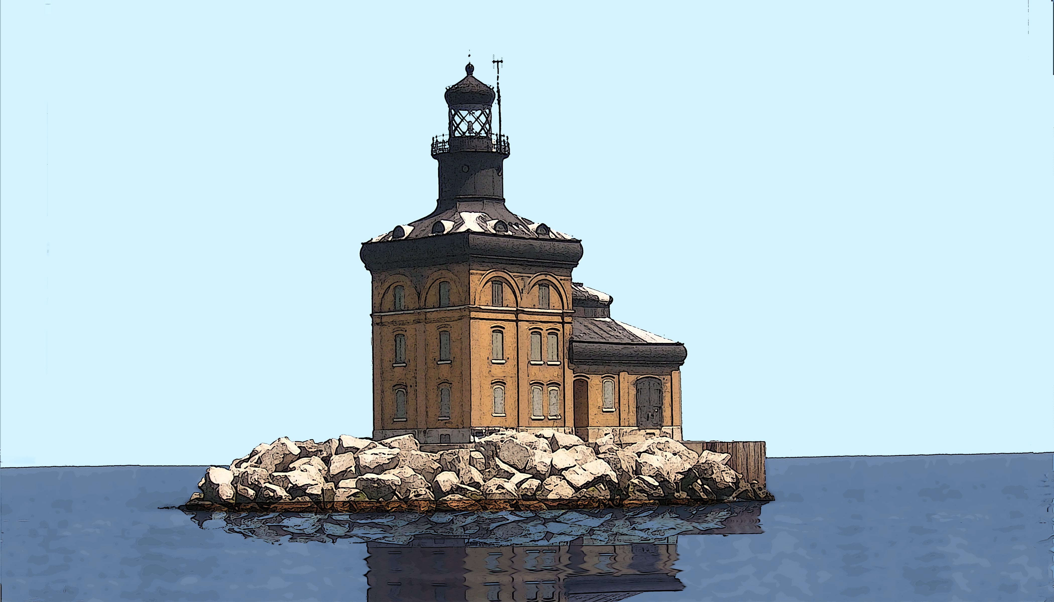
TOLEDO HARBOR LIGHT SOCIETY

www. toledolighthousefestival.org

Pat Price 419-693-1778 watcher725@aol.com

Carol Lampkowski 734-856-6249 clamp@buckeye-express.com

10th ANNIVERSARY TOLEDO LIGHTHOUSE WATERFRONT FESTIVAL
July 13th & 14th, 2013 Maumee Bay State Park Saturday 10a.m. - 8p.m. Sunday 10a.m. – 5 p.m.

Dear Silent Auction Donor:
The 10th Anniversary Toledo Lighthouse Festival will be very special with BP sponsoring the Toledo Symphony Saturday evening. Additional entertainment includes the American Legion, summer music, steel drums, and a very entertaining magician. The nautical arts and crafts village has over 50 exhibitors. There will also be lighthouse boat rides, children's activities, sand castles, fest foods, and more. The Toledo Lighthouse Waterfront Festival is Toledo’s/Northwest Ohio’s signature nautical festival on the shores of Maumee Bay/Lake Erie. The festival celebrates the Historic 1904 Toledo Lighthouse which marks the Toledo shipping channel guiding boats from Lake Erie thru Maumee Bay to the Maumee River .
The all volunteer nearly 600 member Toledo Lighthouse Society took ownership of the lighthouse in 2006. The organization is a nonprofit 501c3 whose mission is to Promote and Restore the architecturally unique Toledo Lighthouse. The festival helps to provide the match for grants to fund the $1.5 million lighthouse restoration. The restored lighthouse will have four 'Keepers' at the lighthouse welcoming guests for tours. The organization has a $500,000 grant for new windows, doors and brick tucking which requires a $136,000 match. The 'My Lighthouse Window Campaign' has raised over $40,000 and still has windows available. The lighthouse festival is the main fund raiser to help the lighthouse. Thousands attend the festival.
Please help the Toledo Lighthouse 10th Anniversary Festival with a donation to the silent auction. The over 200 item silent auction is a major fund raiser for the all volunteer nonprofit Toledo Lighthouse Society.
All proceeds, net of festival costs, go toward historic preservation, restoration and access for the lighthouse.
The silent auction is critical to help with restoration efforts. Donors names and items will be listed on the web site before the festival and in a festival booklet for attendees for donations made by July 5th. 2013.
---------------------------------------------------------------------------------------------------------------------------------------

Toledo Lighthouse Festival Silent Auction Donation

Send to: Toledo Lighthouse Society c/o Maumee Bay Resort,
1750 Park Rd. #2, Oregon, Ohio 43616, Fax 419-691-2288.

Business Name:__________________________________________

Contact Name:___________________________________________

Address:________________________________________________

Phone No.______________________ E-Mail________________________

Item(s) Donated________________________________________________

Retail Value: __________________________________________________

Proceeds go to the Toledo Harbor Light House Society for the promotion, restoration and preservation of the lighthouse. Silent Auction ends Sunday July 14th at 4 p.m.

